Title: Installation of Windows 11
Author: Darius Ceazar Luna
Date: October 31, 2025

Table of Contents

- Objection
- Prerequisites
- Step-by-Step Installation
- Conclusion

Objective

The objective of this project is to demonstrate the process of installing Windows 11 by simulating the installation in a virtual environment using VirtualBox. This documentation aims to provide a clear, step-by-step walkthrough of the installation process, highlighting system requirements, configuration steps, and post-installation setup. The project showcases practical knowledge of operating system installation while offering a safe, controlled environment for learning and experimentation.

Prerequisites

Before starting the installation of Windows 11 in VirtualBox, ensure the following requirements are met:

1. Hardware & System Requirements (Host PC)
- Processor: 1 GHz or faster with 2 or more cores (64-bit)
- RAM: Minimum 4 GB (8 GB recommended for smooth VM performance)
- Storage: At least 64 GB free disk space
- Internet Connection: Recommended for downloading updates
2. Software Requirements
- Virtualization Software: Oracle VirtualBox (Version 7.0 or higher)
- Windows 11 ISO: Official ISO from Microsoft
3. Virtual Machine Configuration
- Name: Windows 11 VM
- Type: Microsoft Windows
- Version: Windows 11 Enterprise (64-bit)
- Memory (RAM): 4096 MB (or higher depending on host capability)
- Virtual Hard Disk: Minimum 64 GB (VDI format, dynamically allocated)

Step-by-Step Installation

This section details the process of installing Windows 11 Enterprise on Oracle VirtualBox (Version 7.0). The steps begin with downloading the official Windows 11 ISO and proceed through setup, configuration, and verification.

Step 1: Download the Windows 11 ISO

- Visit the official Microsoft Evaluation Center:
https://www.microsoft.com/en-us/evalcenter/evaluate-windows-11-enterprise

- Click “Download the ISO – Windows 11 Enterprise” under Get started for free.

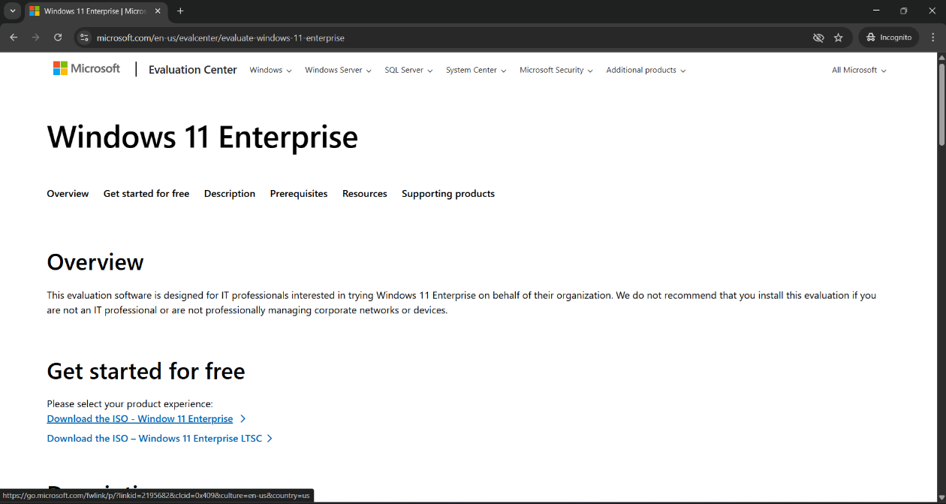

- Fill in the registration then click download now down below.

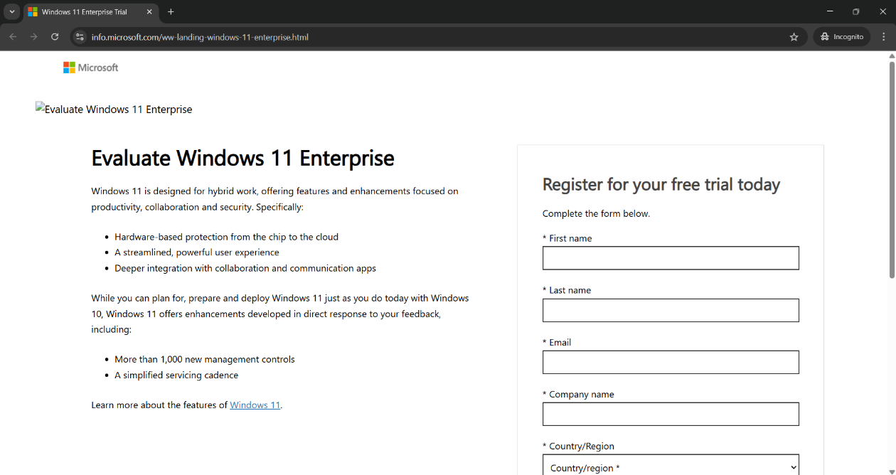

- Choose 64-bit ISO as the download option.

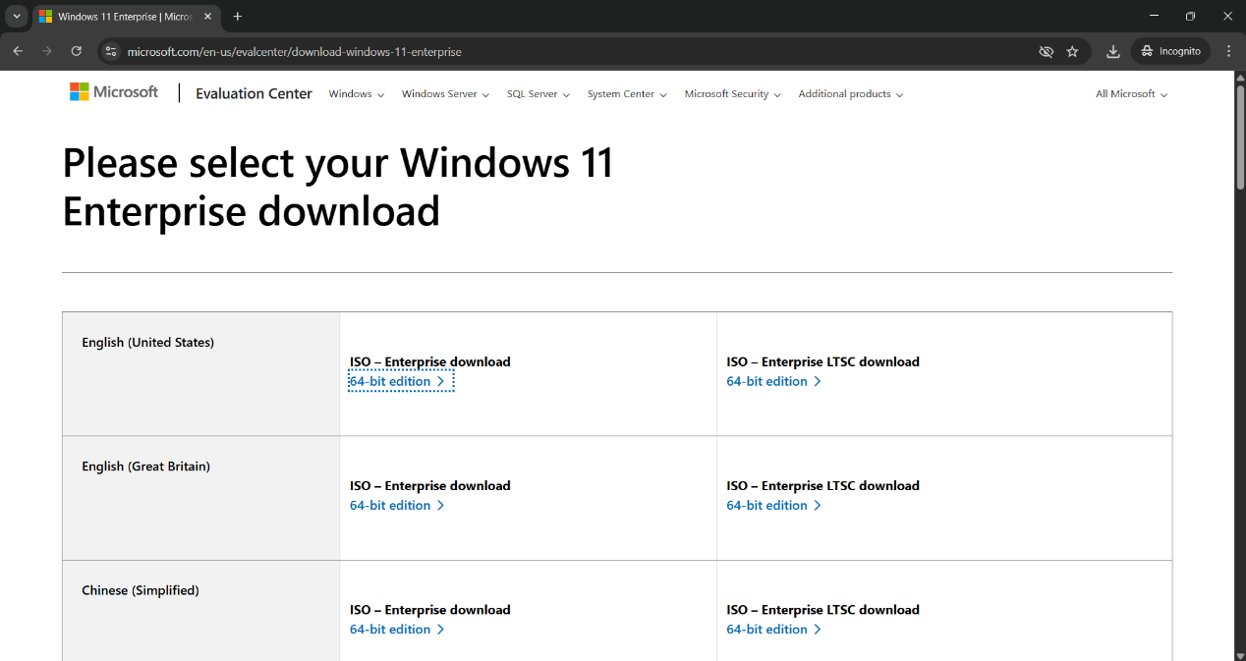

- Wait for the ISO file to finish downloading (around 6 - 7 GB).

Tip: For starters save the ISO file in the Downloads folder for easier access later.

Step 2: Launch VirtualBox and Create a New Virtual Machine

- Open Oracle VirtualBox.

- Click “New” to create a new virtual machine.

- Enter the following details:
  - Name: Enter your preferred name
  - ISO Image: Select the downloaded Windows ISO file
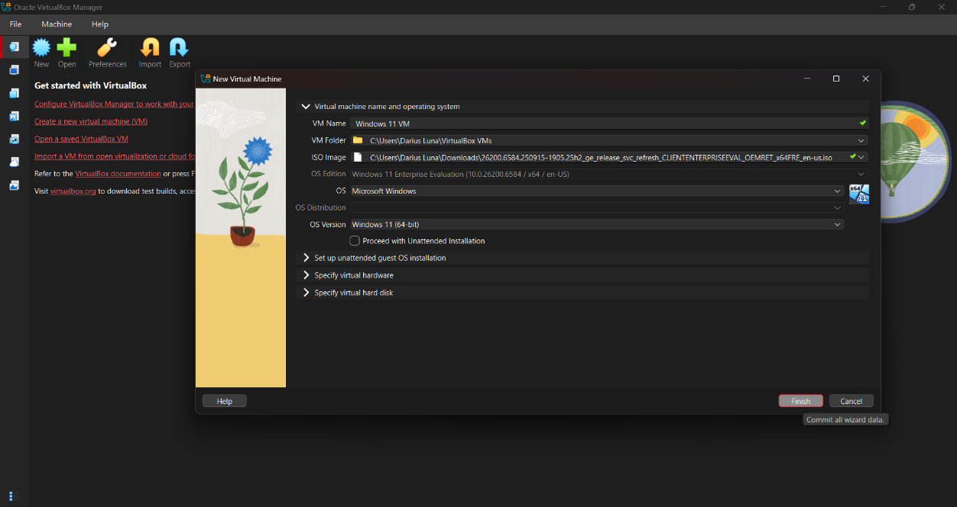

- Set the preferred memory size (4 GB or higher).

- Set the preferred CPUs to allocate to the VM (2 recommended or higher).

- Also make sure to uncheck Unattended Installation.

- Click Next to continue.

Note: Allocating higher improves performance for the VM but too much may reduce the performance of the host machine.

As you can see below, I allocated 8GB of RAM and 4 CPUs, you can also see additional VM information below.

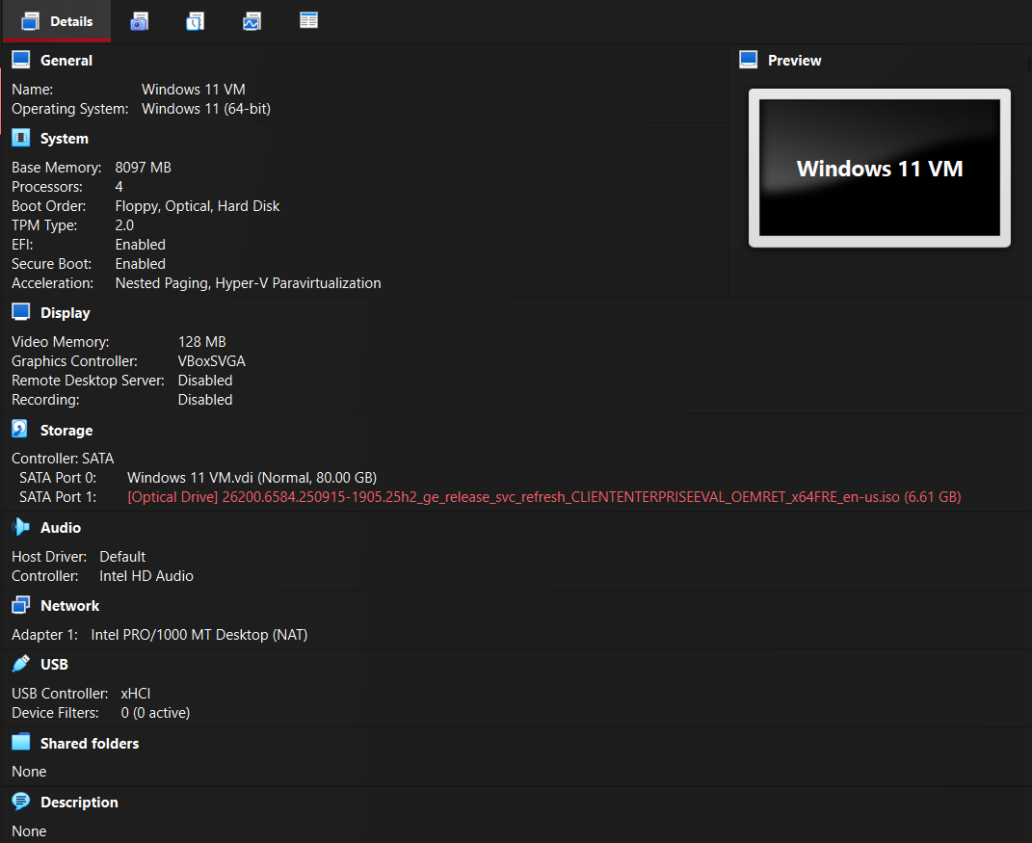
Step 3: Begin Windows Installation

- Choose your language, time and currency format, then click Next.

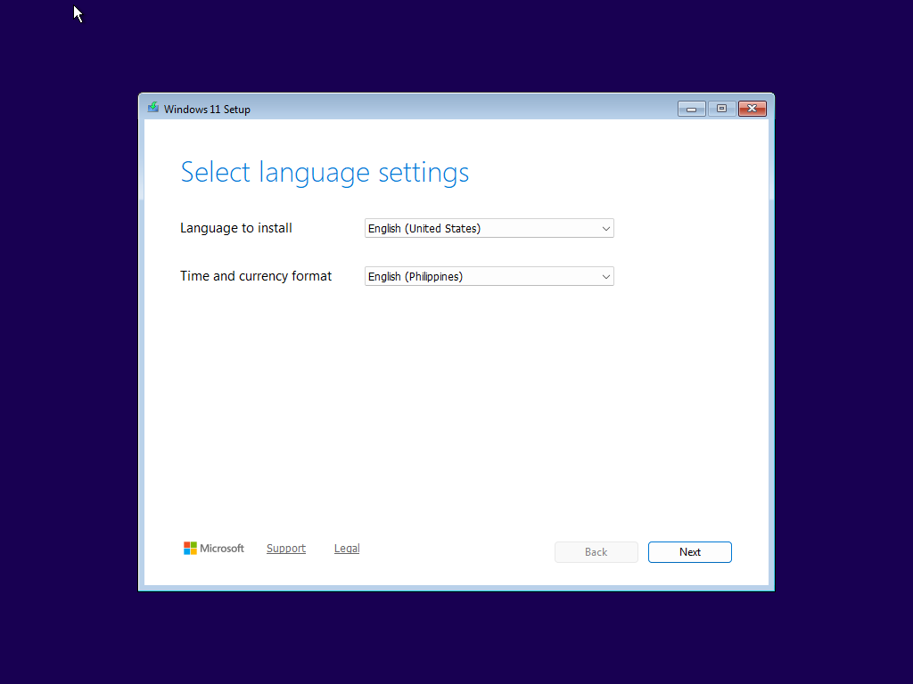

- Choose Install Windows 11.

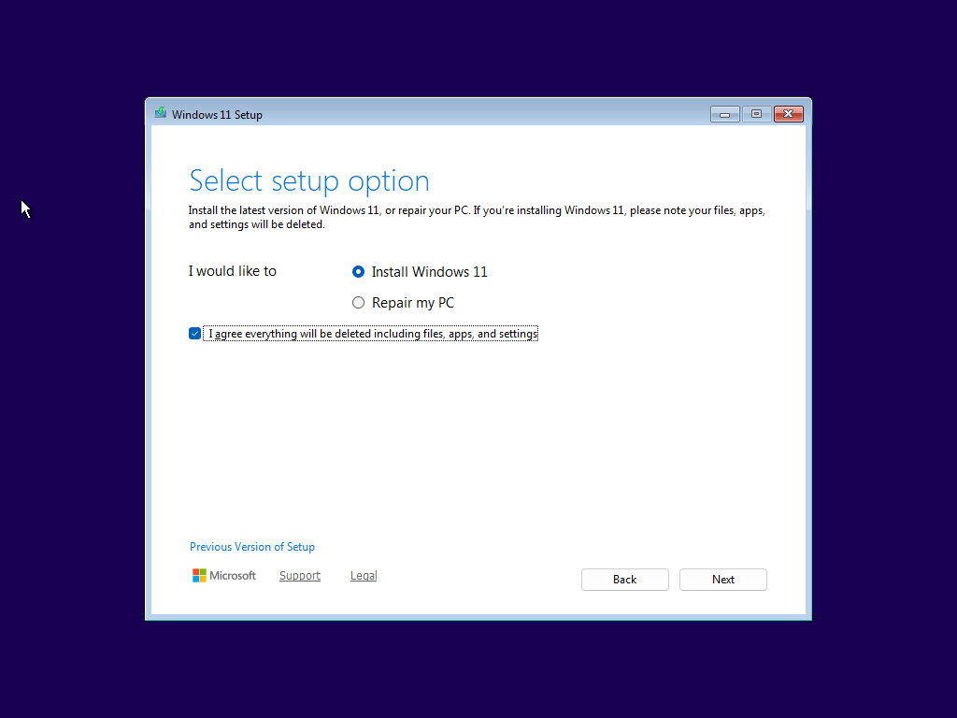

- Leave the most by default.

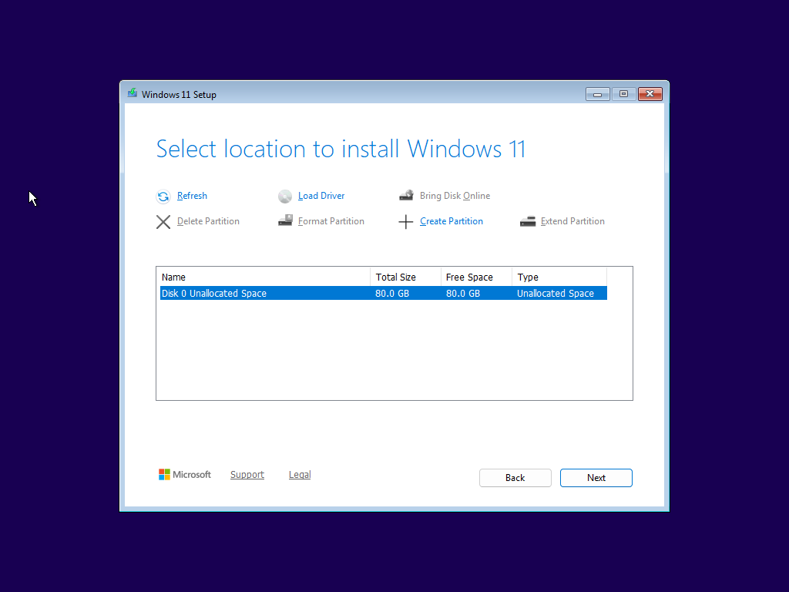

- Accept the license terms and click Next.

- Then click Install.

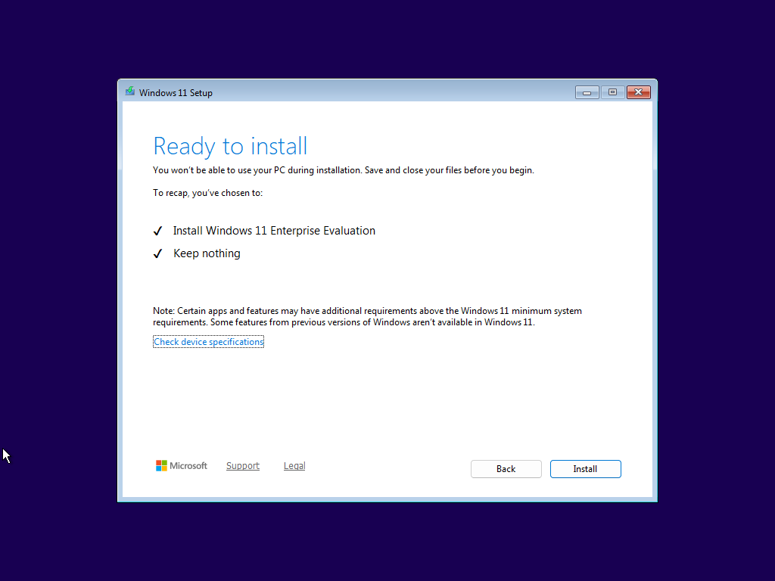

Note: Installation time may take a while based on your host machine’s performance.

Step 4: Complete Initial Setup

- After installation, the system will restart automatically.

- Follow the setup prompts to:
  - Select your region and keyboard layout
  - Create a local user account
  - Adjust privacy and security settings

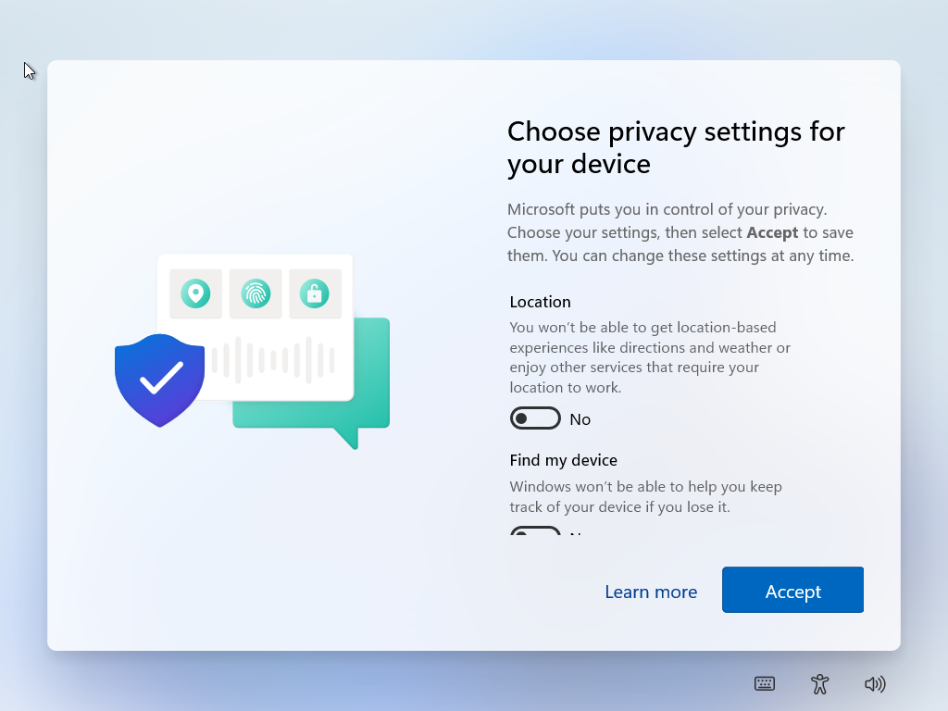

- With Enterprise you need to sign in using your company’s email, click Sign-in options.

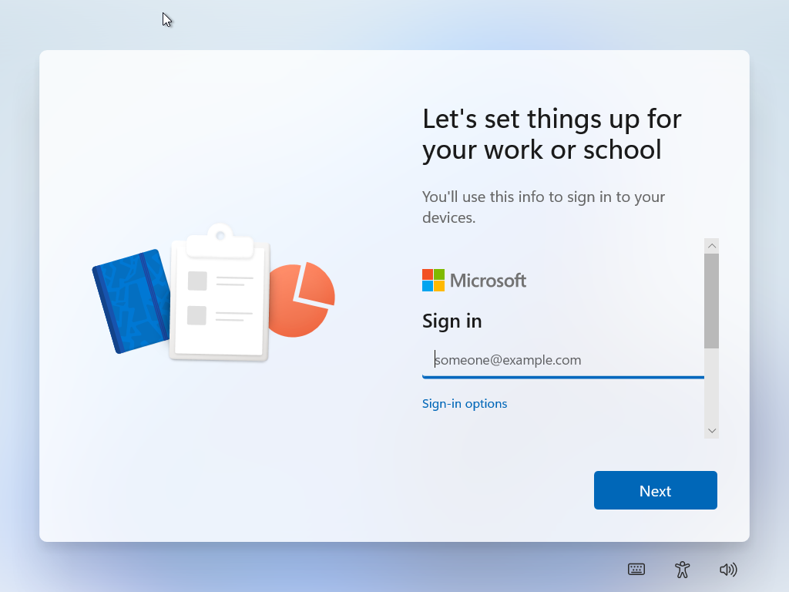

- Then just click Domain join instead.

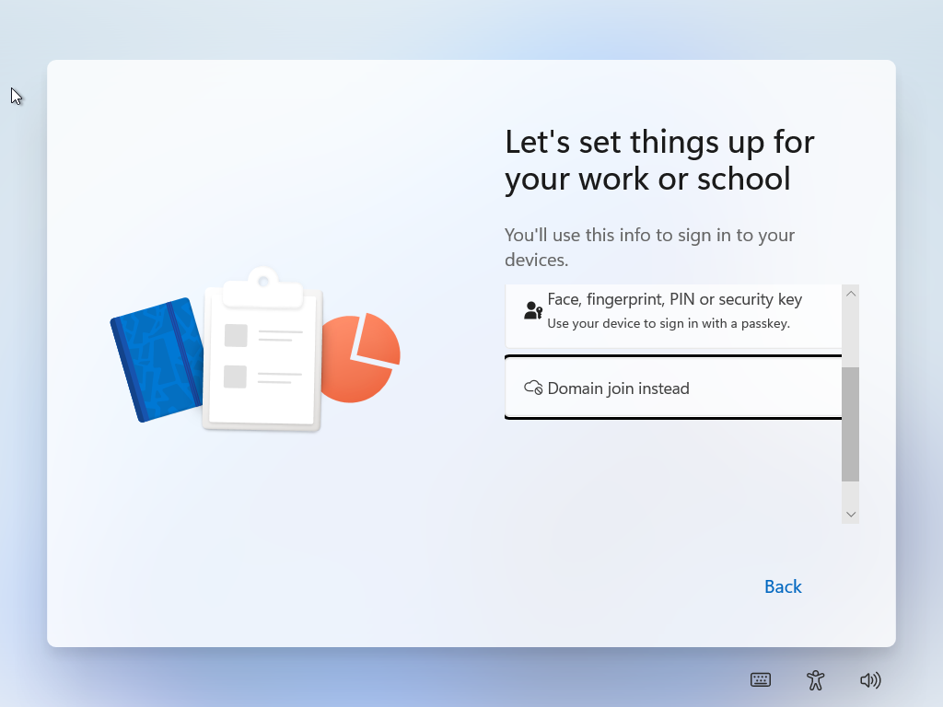

- Finish things up and wait for Windows to prepare your desktop.

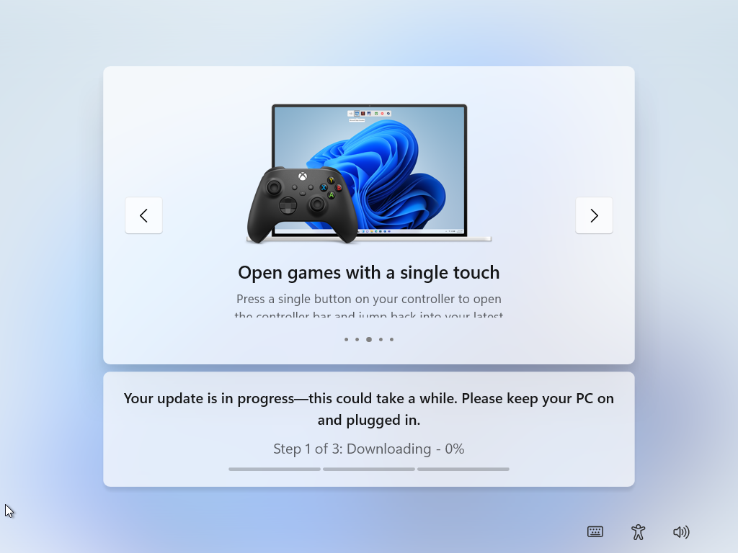

Step 5: Verify Installation

- Once Windows restarts, search to open System Information.

- Confirm:
  - Edition: Windows 11 Enterprise Evaluation
  - System Type: 64-bit OS
  - Memory: Matches your VM configuration

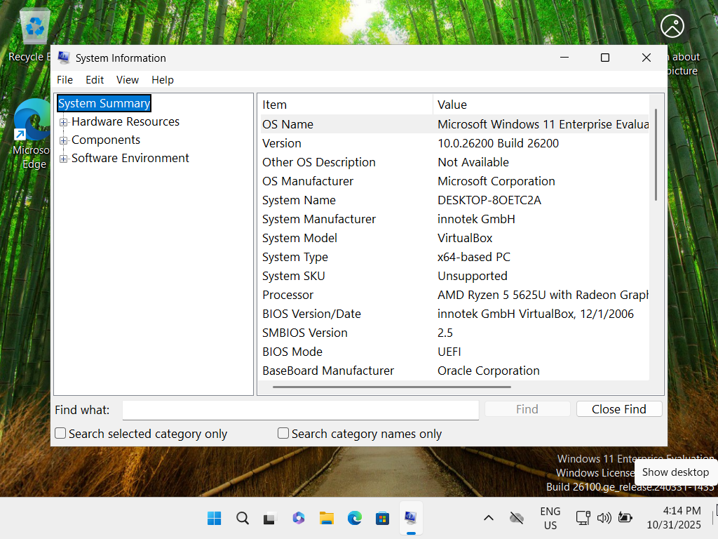

- END

Conclusion:

In this project, I successfully demonstrated how to install Windows 11 Enterprise using Oracle VirtualBox. By simulating the installation process in a virtual environment, I was able to explore each stage of the setup, from downloading the ISO file and configuring virtual hardware to completing post-installation tasks and system verification.

Overall, this project demonstrates practical IT skills in system deployment, virtual machine management, and technical documentation, reflecting both theoretical knowledge and real-world application, essential competencies for any aspiring IT professional.

References

Microsoft. (2025). Download Windows 11 Enterprise (Evaluation Center).
Retrieved from https://www.microsoft.com/en-us/evalcenter/evaluate-windows-11-enterprise

Microsoft Support. (2025). Windows 11 system requirements.
Retrieved from https://support.microsoft.com/en-us/windows/windows-11-system-requirements

Oracle Corporation. (2025). VirtualBox User Manual.
Retrieved from https://www.virtualbox.org/manual/

